**Assignment 7**

**Develop a simple, RMI-based server**

**(CatServer), which will allow a client to read a text-file line by line.**

**i.e. the server provides the following methods:**

**· public boolean**

**openFile(String filename) Opens a file, returns true if file is successfully**

**opened, false otherwise.**

**· public String nextLine()**

**Reads and returns the next line from the file. Returns null if end-of-file is**

**reached or if no file has been opened.**

**· public boolean**

**closeFile() Close the file which is currently open. Returns true if the file is**

**successfully closed, false otherwise.**

**Starting rmiregsitry:**

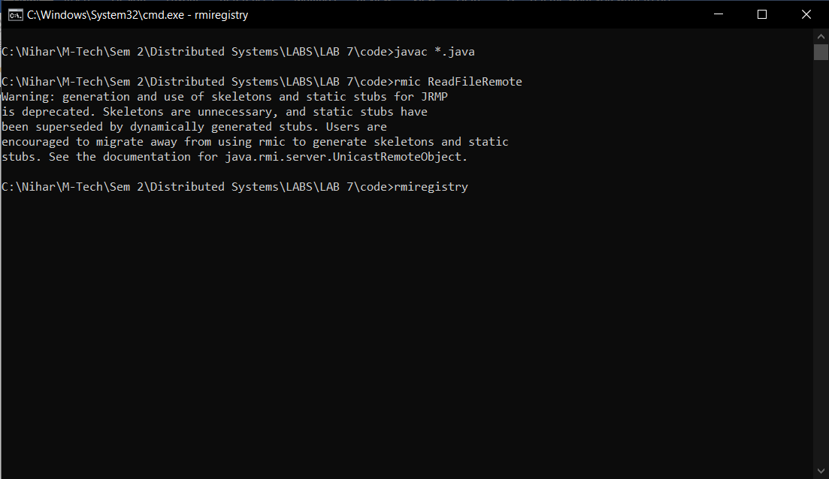

**Server:**

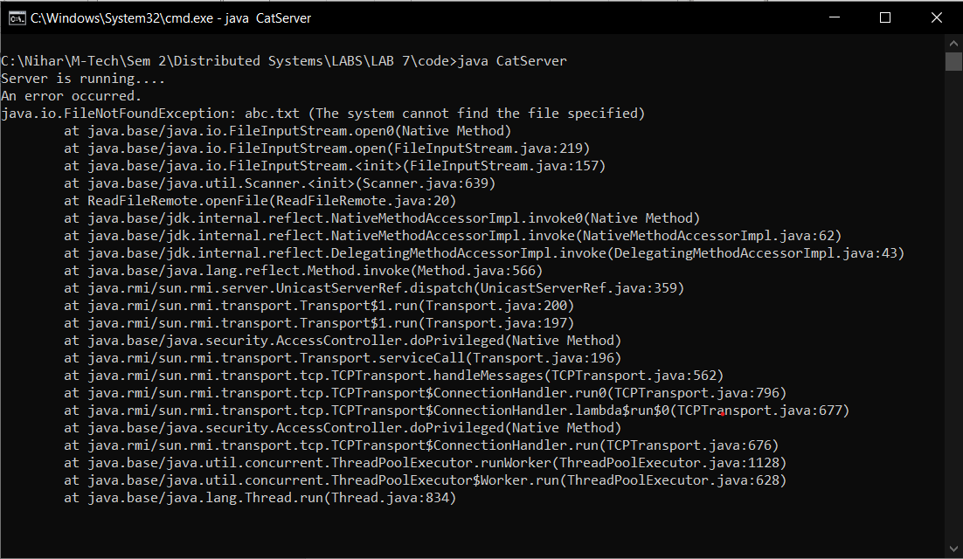

**Client:**

